food | Approx. carbs | visual | food | Approx. carbs | visual
Chips | 10g per 10 chips |  | Panini | 35g | 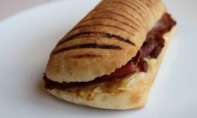
Pasta pot | 50g | 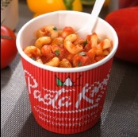 | Toast ( 1 slice) | 47g | 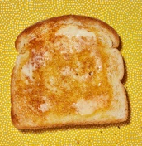
Beef Burger | 30g | 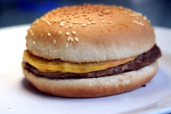 | Bagel | 15g | 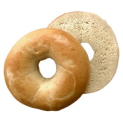
Chicken burger (in breadcrumbs) | 45g | 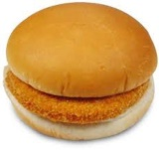 | Toasted teacake | 50g | 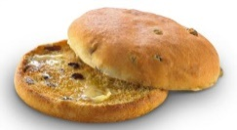
Veggie burger (in breadcrumbs) | 40g | 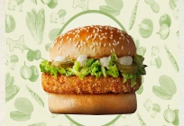 | Bacon/sausage teacake | 43g | 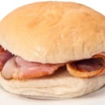
Pizza slice | 30g | 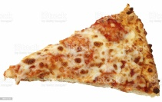 | Sandwich without a food label  (take carbs from the food label if it has one) | 30g | 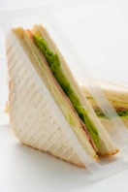
Wrap  (add extra if the fillings has a breadcrumb coating eg chicken) | 35g | 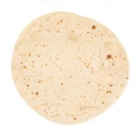
approximate carbs in common high school meal choices

