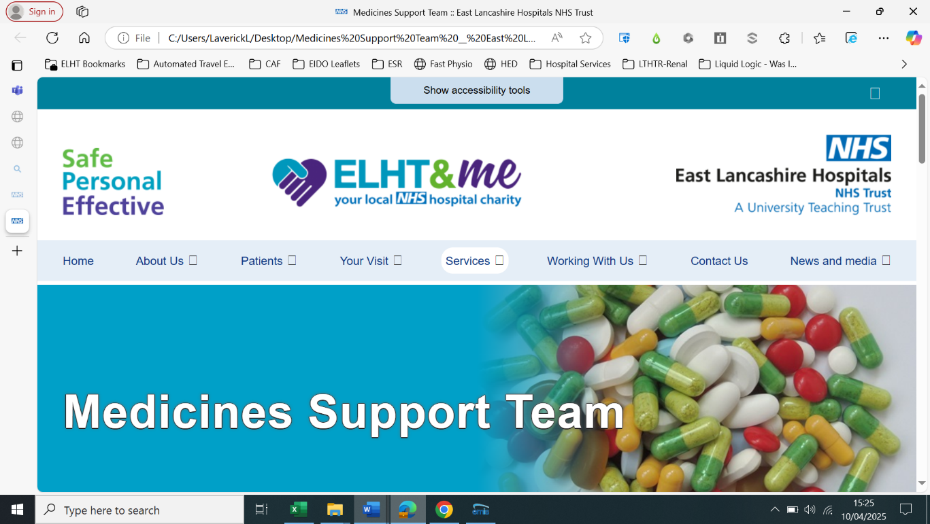

Medicines Support Team Referral Form

**Request for Medicines Review, Home Assessment, Medicines Advice and Review of Support Needs**

We aim to arrange appointments within 10 working days of receipt. Please contact the service if you need to discuss further.

|  |  |  |  |
| --- | --- | --- | --- |
| **Name of patient** | | **NHS Number** | |
| **Address** | | **Date of birth** | |
| **Telephone** | |
| **Postcode** | |
| **GP practice** | | **GP telephone no.** | |
| **Consent- We are unable to accept referrals without the patient consent.**  □ Patient has consented to referral, viewing shared records, and sharing information.  □ Referral made in best interest (Mental Capacity Act 2005) | | |
|
|
| **Safeguarding**  Can staff visit alone? □ Yes □ No  If NO, provide details of known risks to self or others: | | | |
| **Referral Criteria**  □ Dexterity Problems □ Difficulty remembering or managing medication □ Falls risk □ Recent Hospital Discharge □ Recent changes to Medication □ Swallowing difficulties  □ Education about medicines □ Complex medication regimens □ Adverse drug reaction  □ Other……………………………………………………………………………………………………………………………………………………………………………  **Reason for Referral** Please give clear details to support triage. (Continue on page 2 if necessary). | | | |
| **Who should the visit be arranged with?**  □ Patient □ Representative  Name Relationship Tel Mobile  **Who is responsible for medicines?**  □ Self-administers □ Family Support □ POC □ Other  **Does the patient have any communication needs:**  □ Language difficulties – Language Spoken…………………………………………… □ Hearing Difficulties □ Visual Impairment  □ Communication issues – (please state)……………………………………………………………………………………………………………. | | | |
| **Name of referrer** | **Date** | | |
| **Occupation / Department** | **Contact details** | | |

# Email completed form to

# 🖂 medicinessupportteam@elht.nhs.uk 🖂 [medicinessupport.elht@nhs.net](mailto:medicinessupport.elht@nhs.net)

✆**Telephone 01282 803170**

**Additional Information / Continuation Sheet**

# Email completed form to

# 🖂 medicinessupportteam@elht.nhs.uk or 🖂 [medicinessupport.elht@nhs.net](mailto:medicinessupport.elht@nhs.net)

✆**Telephone 01282 803170**