**Appendix 1 ELHT Twiddlemuff Knitting Pattern**

Do you knit? Have you heard of Twiddlemuffs? They’re a knitted band a patient can twiddle in their hands on the wards. They help stimulation and can often reduce distress. We’ve found they are simple and valuable to our patients. We’d be delighted if any willing knitters out there could help us to create more Twiddlemuffs as part of our dementia awareness work. You can drop off completed Twiddlemuffs at any ELHT reception.

If you have any questions, please contact the ELHT Volunteer Service on **01282 803667**  for more information.

Below is a guide on how to knit a Twiddlemuff. Please follow our guidance and do not add any additional materials that could be a choking hazard.

# Materials

* Needles; 6.5mm straight needles or 8mm circular needles.
* Different textures of wool as you can create different senses.

**Please note: some textures of wool are unsuitable, particularly those with loose fibres that can be easily pulled out, as these can pose a choking hazard.**

* Knitted buttons or flowers.
* Large pieces of ribbon/velvet/lace.
* Pieces of brightly colored material to stitch into the muff.
* Fleece or another soft material to line the inside of the muff (not all muffs need to be fleece-lined – those that are can be used for patients that may have dressings on hands/arms).

***Decorating***

* Please **do not** use any buttons/beads/bells or attachments that can be pulled off as these items could be a hazard to the patient. Be cautious of attaching zips, as some may cause damage to the skin of our older patients.
* When using large pieces of ribbon/lace/velvet, please secure with a knit stitch over the middle of the ribbon to ensure it stays on.
* Knit in the shape of flowers and buttons using different textured wool.
* Consider sewing a pocket on the front for busy hands.
* **Please note: all suitable decorations must be securely attached and not leave gaps that fingers or cannulas could become trapped in.**
* **Please note: Unsuitable items will be removed before being given to a patient.**

***Pattern***

***Cuff***

* Cast on 40 stitches using 2 strands of double knitting wool and you can also use 1 strand of chunky wool if wanted.
* Work in stocking stitch (knit a line, purl a line) for 11 inches (28cm).
* Consider stitching in the fleece to create the lining (if applicable).

***Muff body***

* Continue with stocking stitch. This is a great way to use up any old bits of leftover wool (for example – chunky, rainbow)
* Knit body until it measures 23 inches (58.5cm).
* Cast off

***Finishing***

* Neatly sew along the edges together with purl side facing you.
* Turn the muff inside out.
* Push the cuff (lining) up inside the muff body and neatly sew the cast on and cast off edges together.

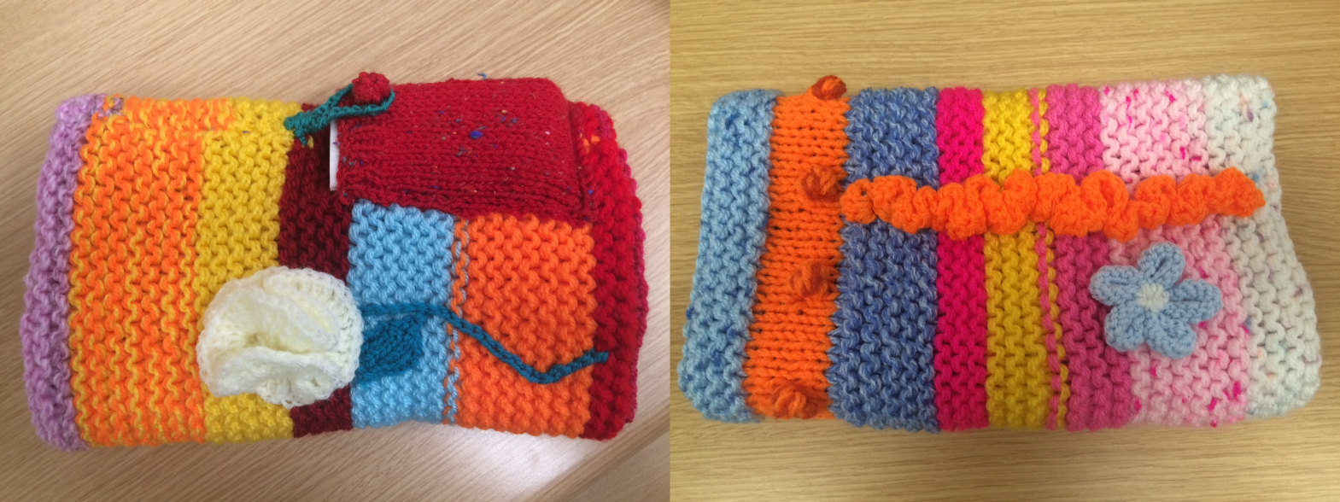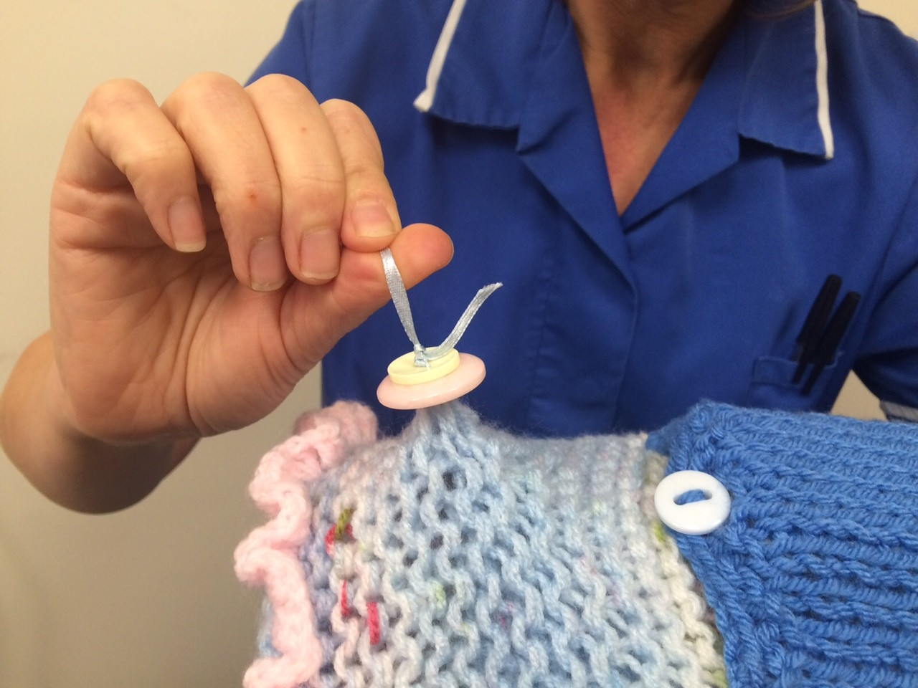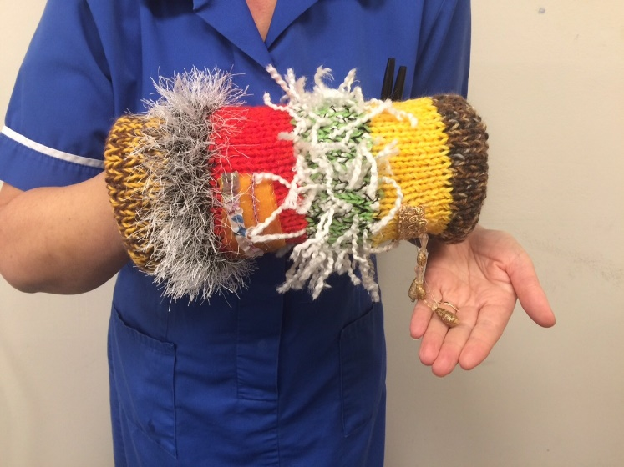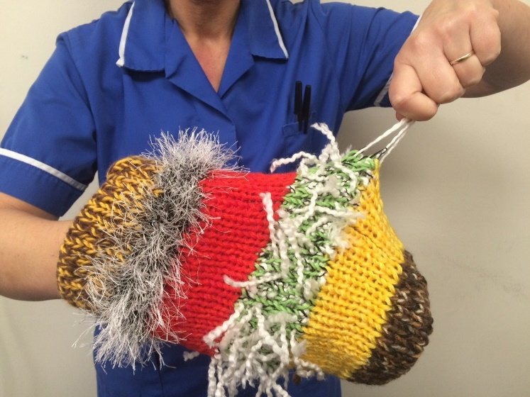

**Please avoid using any items that can be pulled off or removed as they may create a hazard to your patient**