If you have been invited to a virtual clinic or session with the dietitians at ELHT we will be using Microsoft Teams. Please take the time to read the relevant parts of this user guide carefully before taking part.

To access the sessions all you need is:

* A laptop, tablet, smartphone, or desktop computer
* A reliable internet connection
* A private, well-lit area

* Microsoft Teams app, available below.



[**Android**](https://play.google.com/store/apps/details?id=com.microsoft.teams&lm=deeplink&lmsrc=downloadPage&cmpid=downloadAndroidGetApp)



**iOS (Apple)**



[**Windows**](https://www.microsoft.com/en-gb/microsoft-teams/download-app#desktopAppDownloadregion)

To access your virtual group dietitian appointment, click the link in your invitation email or text message. You will then be prompted to enter your name and to click ‘**Join**.’

On the next screen **always** select to open in ‘**Teams’**

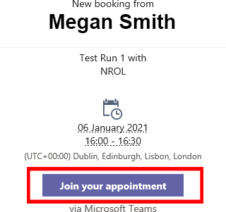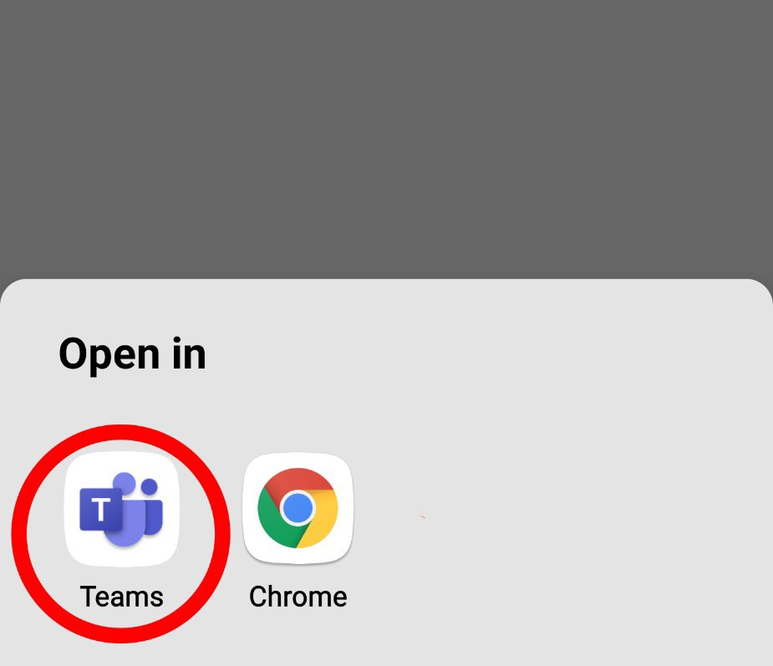

*It is advisable to click on the session invite early to allow time to resolve any connection issues.*

Your device may ask for permission to access the internet. Select **allow.**

If you haven't previously downloaded Microsoft Teams at this point you will be asked to do so. Follow the on-screen instructions to download the Teams app.

You may also be asked to allow the use of the camera and microphone select **allow** for both.

Type your name and select **‘Join.’**

When available, a team member will then admit you in to the session.

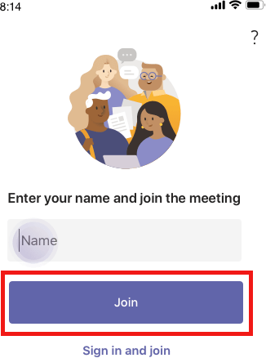

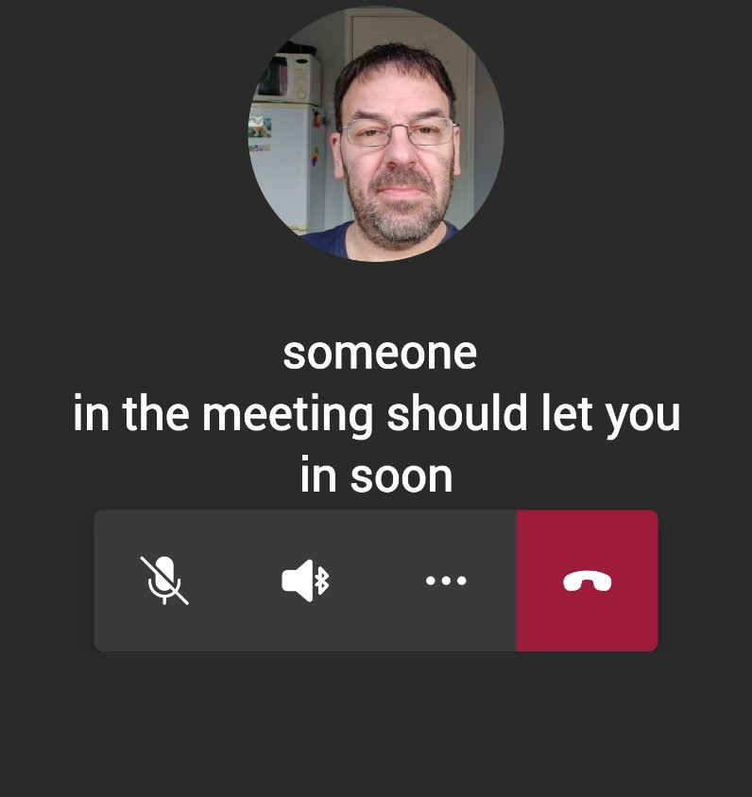

Once you have been admitted to the session you should see the following controls at the bottom of your screen:



video on/off

mic on/off

sound up/down

end meeting



After a short period of time, the controls at the bottom of your screen will disappear, to bring them back, simply tap on the screen.

A team member will advise you when to mute or unmute your mic.

When the virtual group dietitian appointment session has finished, tap the end meeting button on the right of the controls.

To access your virtual group dietitian appointment session click the link in your invitation email or text message, you will then be prompted to enter your name and to click ‘**Join**.’





If your device asks for permission to access the internet when tapping on ‘**Join your Appointment’**, select the appropriate option to allow it to do so.



After a short period of time, the controls at the bottom of your screen will disappear, to bring them back, simply tap on the screen.

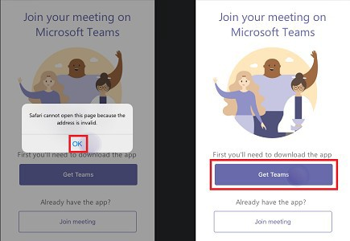

You will see the following message if you have not yet downloaded the Teams app, click ‘**OK**’, then click- ‘**Get Teams**’ and follow the instructions given.

This screen will show while you wait for a team member to admit you in to the session.



Once you have been admitted into the session you will see the following controls at the bottom of the screen



*video on/off*

*mic on/off*

*sound up/down*

*end meeting*



After a short period of time, the controls at the bottom of your screen will disappear, to bring them back, simply tap on the screen*.*

The DIETETIC team member will advise you when to mute or unmute your mic.

When the virtual group dietitian appointment session has finished, tap the end meeting button on the right of the controls.

To access the virtual group dietitian appointment session, click ‘**Join your Appointment’** in your booking email.



If this window appears select one of the following:

If you want to open it in the browser

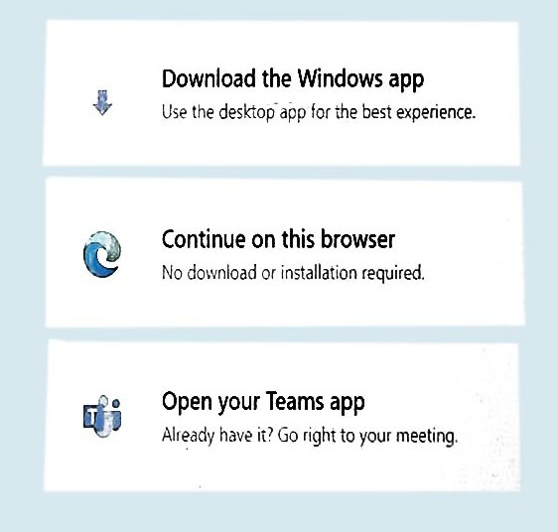

If you have the Teams app already installed on your device

If you haven't already downloaded the Teams app



It is advisable to click on the session invite early to allow time to resolve any connection issues.

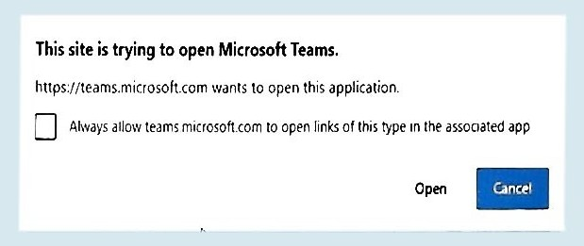

The first time you open the Teams app, you may see this window pop up at the top of the screen.

Click inside the tick-box then select Open.

A message may also appear when Teams is used for the first time, asking for permission to use the camera and mic, select ‘**Allow**’.

Once the Teams app opens, you will be presented with a preview screen where you can make sure the camera is positioned correctly and switch on or off your camera and mic.

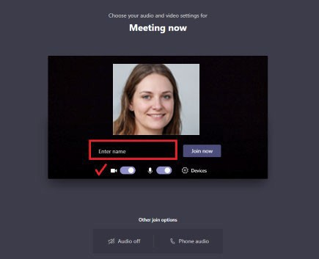

Join group

Video on/off Mic on/off

When you are happy with the settings on screen, click ‘**Join now**’ and a team member will admit you to the meeting when available.

When you enter the virtual group dietitian appointment session you may see other people on the screen or just a dietetic team member, this is normal.

Your camera video will always be in the bottom right of the screen.

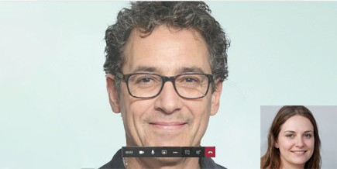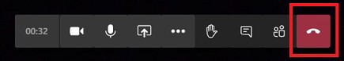

Video on/off mic on/off end meeting

A team member will advise you when to mute or unmute your mic.

When the session has finished, tap the end meeting button on the right of the controls.