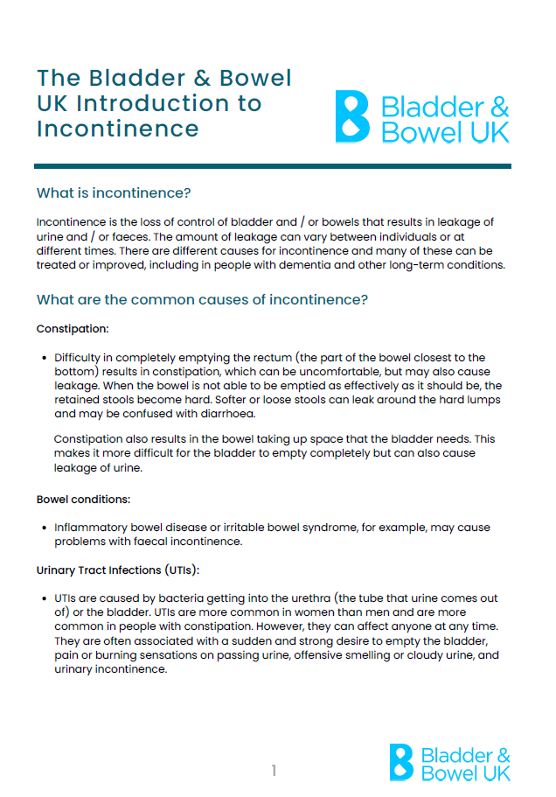
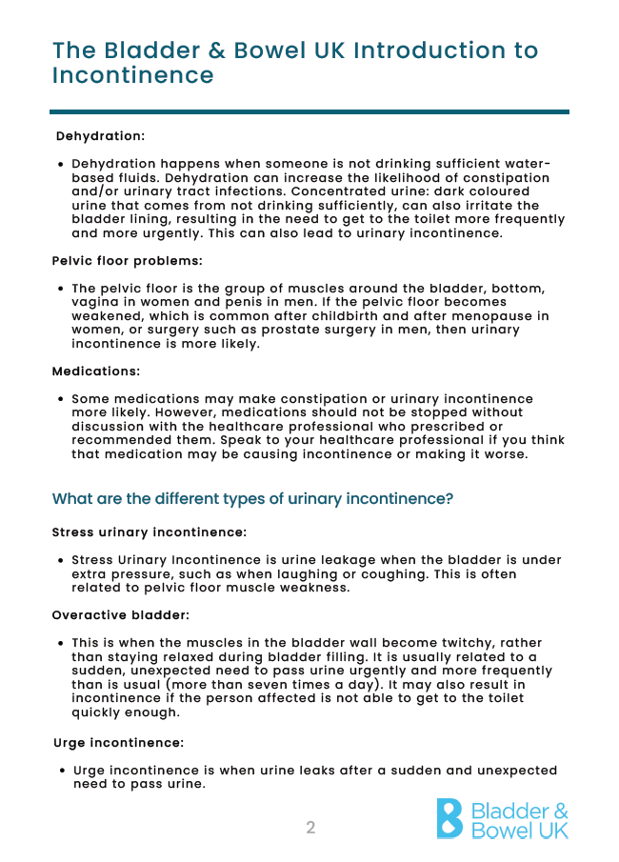




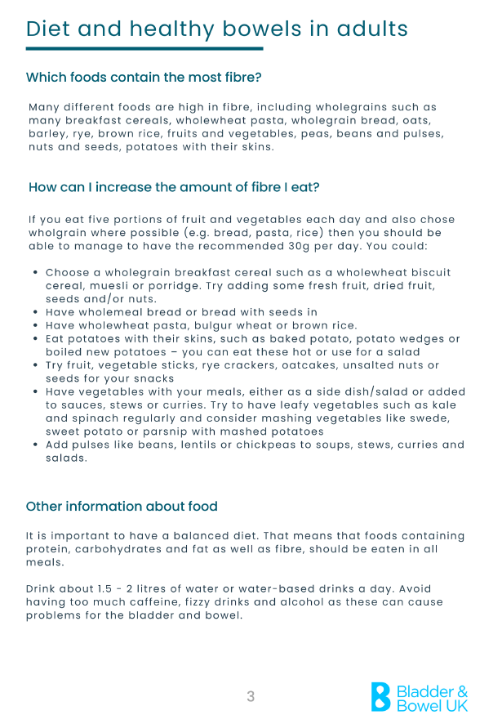


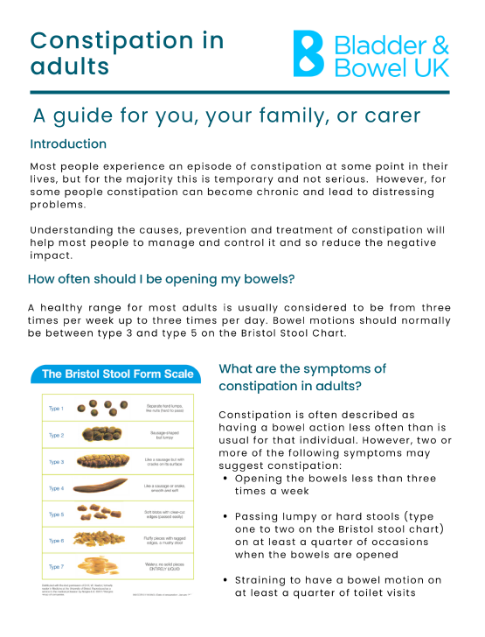

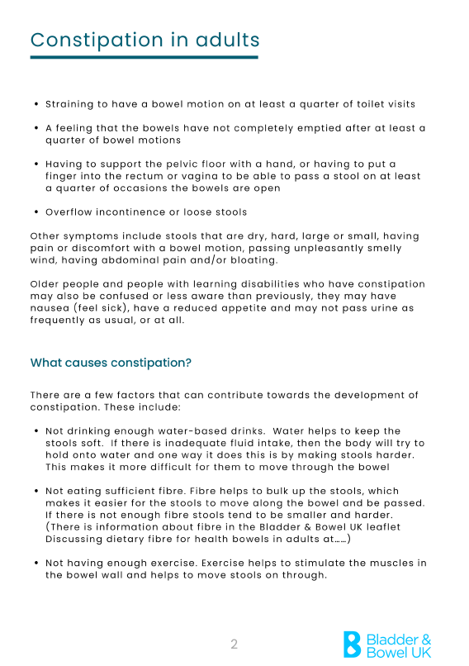

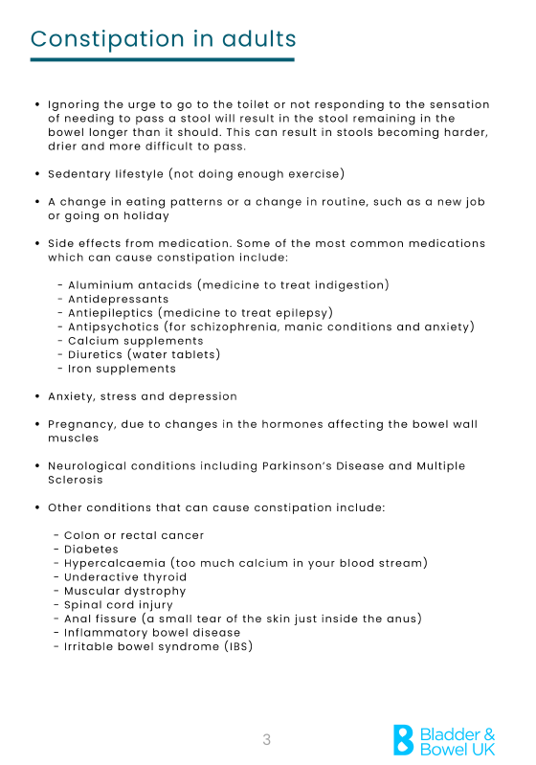

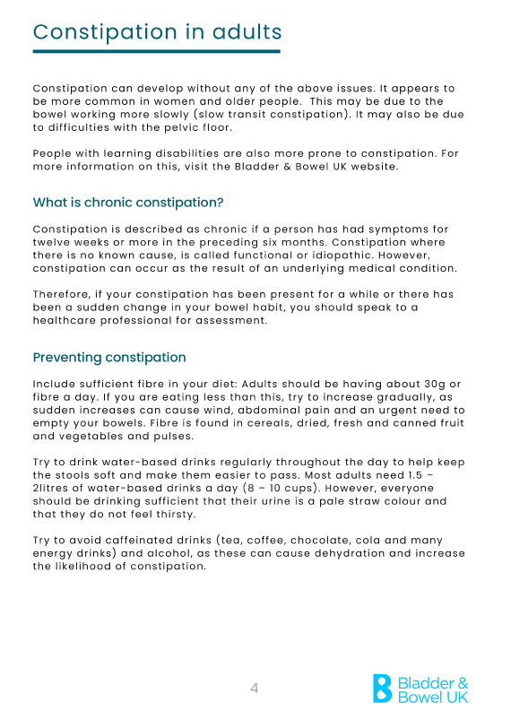

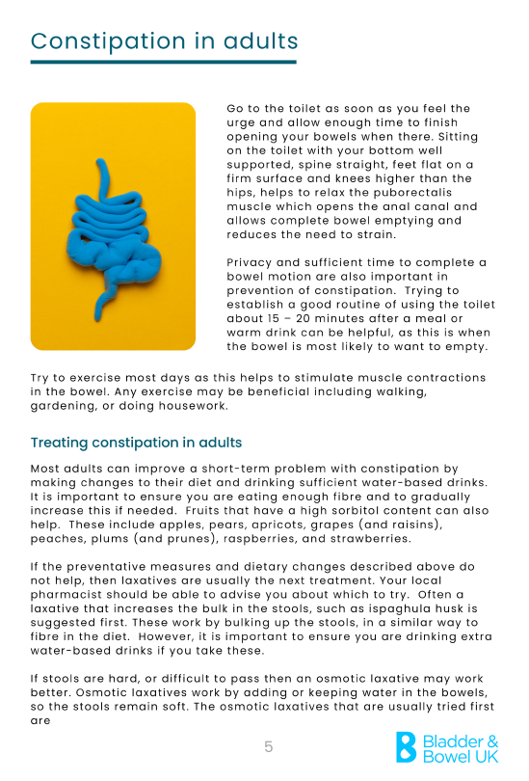
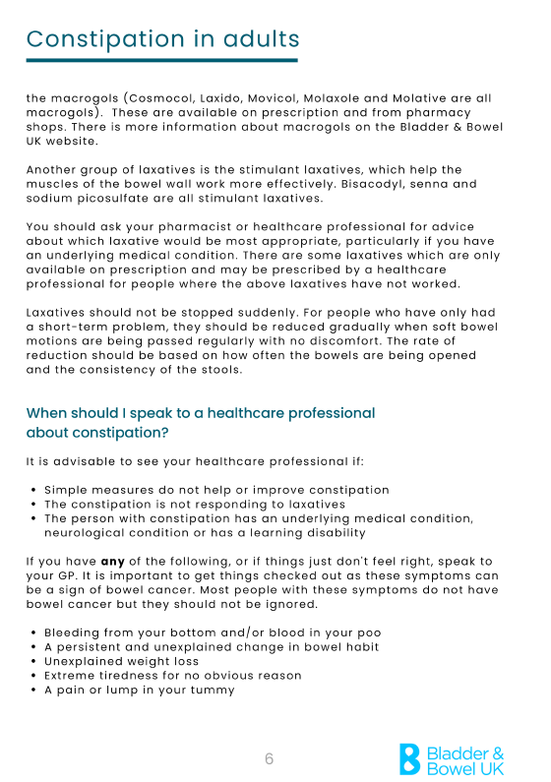

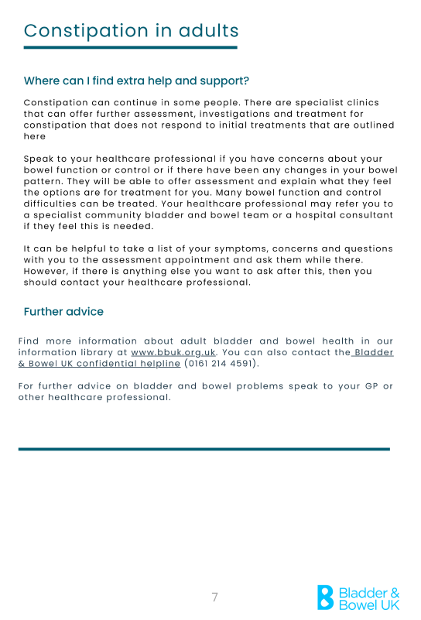

Date: I woke up at: I went to sleep at:

Time | Food/Drink Consumed, Medication (type+amount) | (✓) For each bowel movement | Bowel urgency? 1=mild, 3=strong | Pain/discomfort? 1=mild, 3=strong | Stool Type (see Bristol Stool Chart p2) | Record any accidents or leakage
Midnight
1am
2am
3am
4am
5am
6am
7am
8am
9am
10am
11am
Noon
1pm
2pm
3pm



Provider of the Original Just Can’t Wait Card
Website: www.bladderandbowel.org | Email: help@bladderandbowel.org

4pm
5pm
6pm
7pm
8pm
9pm
10pm
11pm
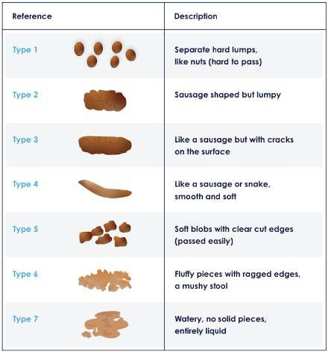

When completing this diary please refer to the Bristol Stool Chart, available left or to download in full from our website.
Visit bladderandbowel.org/downloads

Keeping a record of medications, what you eat and drink, and bowel movements may highlight certain factors that are causing your bowel problems or making them worse.

Provider of the Original Just Can’t Wait Card
Website: www.bladderandbowel.org | Email: help@bladderandbowel.org

