
Bladder and Bowel Service - Intake/Output Chart for patients referred into the service
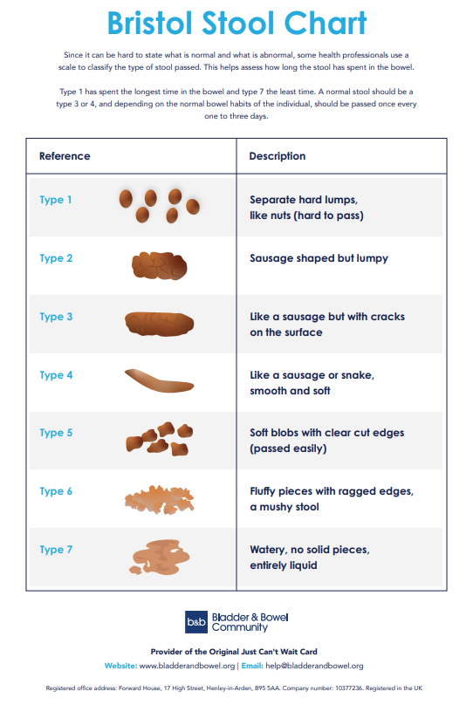
Instructions for patients completing intake/output charts
- Complete all 3 days of diaries for both bladder and bowel- a new diary for each day.
- Please refer to the Bristol Stool Chart to record type of stool passed -see opposite chart
- Complete your name, date, the time you woke and the time you went to sleep on each day for both diaries
- Don’t forget to record what happened overnight when you get up in the morning
- Record things to the nearest hour and just after they happen in case you forget later.
- If you are unable to measure your urine output, please put a tick each time you pass urine
- Record type and number of drinks, for eg 2 cups of tea, 1 mug of coffee, I can of coke, 1 glass of water)
- On completion, please return by e-mail to BladderandBowelService@elht.nhs.uk
- Please contact the service on 01254 735002 if you have any concerns or require any help with this.
- Return completed diaries within 2 weeks to prevent being discharged from the service.
- If clinically required, you may be asked to complete further diaries

Day One- Date: ……………………………
Name: |  |  |  |  | DOB: |  |  | I woke up at: |  |  | I went to sleep at:
Time: | Bladder |  |  |  |  |  |  |  | Bowel
Time: | In (drinks consumed)   mls |  | Out (passed urine)  mls | From the following options, each time you leaked urine, please record whether you were: almost dry, damp, wet or soaked |  |  | Notes including changed pad/panty liner, accidents or leakage |  | for each bowel movement | Bowel Urgency? 1=mild, 3=strong |  | Stool type (see Bristol Stool Chart P1) | Record any accidents or leakage

Day Two - Date: ……………………………
Name: |  |  |  |  | DOB: |  |  | I woke up at: |  |  | I went to sleep at:
Time: | Bladder |  |  |  |  |  |  |  | Bowel
Time: | In (drinks consumed)  mls |  | Out (passed urine)  mls | From the following options, each time you leaked urine, please record whether you were: almost dry, damp, wet or soaked |  |  | Notes including changed pad/panty liner, accidents or leakage |  | for each bowel movement | Bowel Urgency? 1=mild, 3=strong |  | Stool type (see Bristol Stool Chart P1) | Record any accidents or leakage

Day Three - Date: ……………………………
Name: |  |  |  |  | DOB: |  |  | I woke up at: |  |  | I went to sleep at:
Time: | Bladder |  |  |  |  |  |  |  | Bowel
Time: | In (drinks consumed)  mls |  | Out (passed urine)  mls | From the following options, each time you leaked urine, please record whether you were: almost dry, damp, wet or soaked |  |  | Notes including changed pad/panty liner, accidents or leakage |  | for each bowel movement | Bowel Urgency? 1=mild, 3=strong |  | Stool type (see Bristol Stool Chart P1) | Record any accidents or leakage

