

**Healthy Eating Diet Sheet**

**Choose from this group daily.**

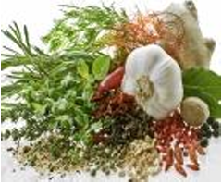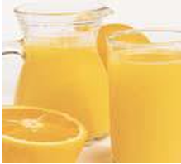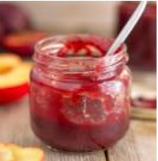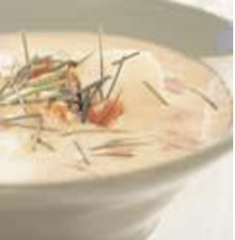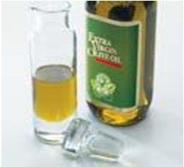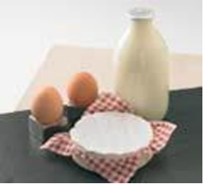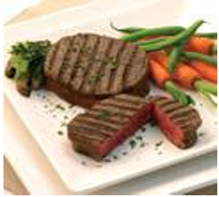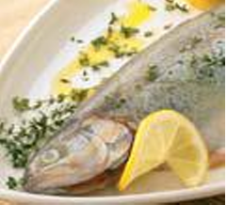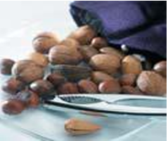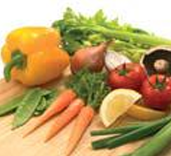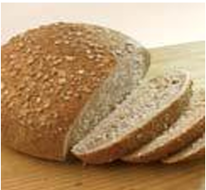

|  |  |  |  |  |  |
| --- | --- | --- | --- | --- | --- |
|  | **Cereal food i.e., cornmeal** | Oatmeal, porridge oats. Wholemeal bread, wholemeal flour, whole grain cereals, crispbreads, brown rice, wholemeal pasta, cornmeal, unfrosted sugar-free muesli, rice cakes. | White bread, white flour, white rice & pasta, water biscuits, wholemeal or oat scone, teacake, pancake. | Sugar-coated cereals. Plain semisweet biscuits. Ordinary muesli. | Sweet Biscuits, cream-filled biscuits (unless cooked in rape seed oil), croissants. |
|  | **Fruit & vegetables** | All fresh, frozen & dried vegetables, fruit, tofu. Eat at least 5-7 portions of different fruit/veg per day, not including potatoes. 1 portion = approx. 80g or the size of a small fist. | Baked potatoes, avocado. | Fruit in syrup, crystallised fruit. Chips & roast potatoes cooked in rape seed oil. Oven chips labelled 'cooked in sunflower oil & 40% less fat' (grill if possible). Olives, unless unsalted. | Deep-fat-fried chips, roast potatoes (unless cooked in rape seed oil). Crisps & savoury snacks. |
|  | **Nuts & seeds** | Small amounts (not more than 25g) of unsalted nuts/seeds daily either as snacks, sprinkled on salad or mixed with dried fruit. |  |  | Coconut. |
|  | **Fish** | All fresh & frozen fish (avoid frying) e.g., cod, plaice, herring, mackerel. 1 portion = 140g about the size of the palm of a hand. | Fish fried in suitable oil (rapeseed, olive, sunflower, corn. Do not use palm or coconut oil). Fish fingers or fish cakes (grilled). Tinned fish in oil (drained) or tomato sauce e.g., sardines, tuna. | Prawns, lobster, crab, oysters, molluscs, winkles. Smoked fish e.g., salmon. | Fish roe, taramasalata, fried scampi. Anchovies. Smoked salmon, haddock, cod, mackerel. |
|  | **Meat** | Chicken, turkey (without skin), veal, rabbit, game, soya protein meat substitute, very lean red meat (grilled). 1 portion = 60-90g, about the size of a pack of cards. | Lean beef, pork, lamb, ham & gammon, very lean minced meat. | Liver, kidney, tripe, sweetbreads. Grilled back bacon (pre-boil in water). Duck (without skin). Low-fat pate. | Sausages, all processed meats, pate, salami, streaky bacon, burgers, goose, meat pies, sausage rolls, pasties, scotch eggs, visible fat on meat, crackling, chicken skin. Ham, gammon. |
|  | **Eggs & dairy foods** |  | Semi-skimmed milk, no more than 3 whole eggs per week including those in baked items e.g., cakes, quiche, flans. | Medium-fat cheeses e.g., edam, camembert, gouda, brie, cheese spread. Half-fat cheeses labelled 'low-fat'. Sweetened condensed skimmed milk. | Whole milk & cream. Full-fat yoghurt, cheese e.g., stilton, cheddar, cream cheese, evaporated or condensed milk, imitation cream, excess eggs i.e., 4 or more per week. |
|  | **Fats & oils** | Small amounts only - see next column. | Olive oil, rape seed oil. | Margarine & shortening labelled 'high in polyunsaturated' or corn oil, sunflower oil, soya oil, safflower oil, grapeseed oil, groundnut (peanut) oil, reduced fat & low-fat spreads. | All margarines, shortenings & oils not labelled 'high in polyunsaturated'. Butter, lard, suet & dripping, vegetable oil or margarine of unknown origin. All spreads not labelled 'low-fat'. Coconut oil. |
|  | **Prepared foods** | Jelly (low sugar), sorbet, fat-free homemade soups. Beware: readymade and processed foods are more likely to contain high salt, unnecessary added sugar, and saturated fats. Always check labels and use the free App FoodSwitch, if necessary. | Homemade pastry, puddings, cakes, biscuits, sauces etc. made with wholemeal flour & fat or oil as above, low-fat ready prepared meals. | Non-dairy ice cream, custard mix made with water or skimmed milk. | Processed pastries, puddings, cakes & sauces made with whole milk & fat or oil as above, suet dumplings or puddings, cream soups. Packet soups. |
|  | **Sweets, preserves, jams & spreads** | Sugar-free artificial sweeteners, low-fat jam & marmalade. | Jam, marmalade, honey low-fat soft cheese, low-fat spreads. | Boiled sweets, fruit pastilles & jellies. Chutneys & pickles, fish & meat pastes, peanut butter. | Chocolate spreads, chocolates, toffees, fudge, butterscotch, carob chocolate, coconut bars. Marmite, Bovril. |
|  | **Drinks** | Freshly made tea, coffee, mineral water, fruit juice (unsweetened). 1 x 150ml glass of fruit juice counts as a portion of fruit. | Alcohol  1-2 Units/day. Maximum 14 units/week - women, 21 units/week - men. | Sweetened drinks, squashes, fruit juice (sweetened), malted milk or hot chocolate drinks made with skimmed milk. | Whole milk drinks, cream-based liqueurs, coffee whitener. |
|  | **Salt, sauces & dressings** | Herbs, spices, lemon juice, garlic, pepper. | Homemade salad dressings & mayonnaise made with suitable oils as above. Low-fat or low-calorie mayonnaise & dressings. | Parmesan cheese. | Salt, tabasco, soy sauce, ordinary or cream dressings & mayonnaise, Worcestershire sauce. |
| **Note: If you are overweight, aim to eat most of your food from the far-left column** | | | | | |
| This diet sheet was originally prepared by Pfizer Ltd in association with BHS. This version has been updated by BIHS 2017. | | | | | |

**Eat in moderation 2-3 times a week only.**

**Eat in moderation once a week or less.**

**Avoid Eating**