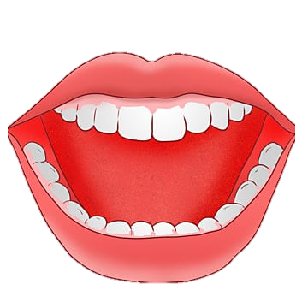

ORAL HEALTH ASSESSMENT TOOL

Resident: Completed by: Date:

**Scores** – You can circle individual words as well as giving a score in each category.

(* if 1 or 2 scored for any category please organise for a dentist to examine the resident)

**0 = healthy 1 = changes* 2 = unhealthy\***

**SCORE:**

**TOTAL:**

With kind permission of the Australian Institute of Health and Welfare (AIHW). Source: AIHW Caring for oral health in Australian residential care (2009).

Modified from Kayser-Jones et al. (1995) by Chalmers (2004).

Organise for resident to have a dental examination by a dentist. Resident and/or family or guardian refuses dental treatment. Complete oral hygiene care plan and start oral hygiene care interventions for resident.

Review this resident’s oral health again on date:

**Gums and tissues:**

**0** Pink, moist, smooth, no bleeding.

**1** Dry, shiny, rough, red, swollen, 1 ulcer or sore spot under dentures.

**2** Swollen, bleeding, ulcers, white/red patches, generalised redness under dentures.

**Tongue:**

**0** Normal, moist roughness, pink.

**1** Patchy, fissured, red, coated.

**2** Patch that is red and/or white, ulcerated, swollen.

**Saliva:**

**0** Moist tissues, watery and free flowing saliva.

**1** Dry, sticky tissue, little saliva present, resident thinks they have a dry mouth.

**2** Tissues parched and red, little or no saliva present, saliva is thick, resident thinks they have a dry mouth.

**Dentures Yes/No:**

**0** No broken areas or teeth, dentures regularly worn, and named.

**1** 1 broken area or tooth or dentures only worn for 1–2 hours daily, or dentures not named, or loose.

**2** More than 1 broken area or tooth, denture missing or not worn, loose and needs denture adhesive, or not named.

**Oral cleanliness:**

**0** Clean and no food particles or tartar in mouth or dentures.

**1** Food particles, tartar, or plaque in 1–2 areas of the mouth or on small area of dentures or halitosis (bad breath).

**2** Food particles, tartar, or plaque in most areas of the mouth or on most of dentures or severe halitosis (bad breath).

**Natural teeth Yes/No:**

**0** No decayed or broken teeth or roots.

**1** 1–3 decayed or broken teeth or roots or very worn-down teeth.

**2** 4+ decayed or broken teeth or roots, or very worn-down teeth, or less than 4 teeth.

**Dental pain:**

**0** No behavioural, verbal, or physical signs of dental pain.

**1** There are verbal and/or behavioural signs of pain such as pulling at face, chewing lips, not eating, aggression.

**2** There are physical pain signs (swelling of cheek or gum, broken teeth, ulcers), as well as verbal and/or behavioural signs (pulling at face, not eating, aggression).

**Lips:**

**0** Smooth, pink, moist.

**1** Dry, chapped, or red at corners.

**2** Swelling or lump, white, red, or ulcerated patch; bleeding or ulcerated at corners.