

Workforce Inclusion Performance report 2024

|  |  |  |  |  |  |  |  |
| --- | --- | --- | --- | --- | --- | --- | --- |
| **PEOPLE AND CULTURE COMMITTEE REPORT** | | | | | **Item** |  | |
| **1 JULY 2024** | | | | | **Purpose** | **Information** | |
| **Title** | | | Workforce Inclusion Performance Report 2024 | | | | |
| **Author** | | | Nazir Makda, Inclusion & Belonging Lead | | | | |
| **Executive Sponsor** | | | Mrs K Quinn, Operational Director HR & OD | | | | |
| **Summary**  Outlines the Trust’s performance against the Workforce Race and Disability Equality Standards and Gender Pay Gap reporting. It identifies the priority areas for action.  Performance against the EDI metrics is not making sufficient progress and there are disparities of experience for colleagues, which is not satisfactory. This needs collective action, and the paper describes the mechanisms by which the Trust will develop greater accountability and responsibility for EDI, as part of our culture and leadership improvement journey. This is vital if we are to deliver safe, personal, and effective care.  This is of increasing importance in relation to the increased levels of international recruitment resulting in greater diverse representation within the workforce, at a time of operational challenge. If we do not develop a more inclusive and compassionate culture this impacts on the quality of care and the experience of our diverse communities.  The Committee is asked to;   * Note the content of this report * Enable an accountability framework that Influences the implementation of the WRES, WDES and GPG improvement action plans at divisional, department, team and individual level * Approve the submission and publication of the data on our corporate website, as per our contractual requirements. | | | | | | | |
| **Report linkages** | | | | | | | |
| Related strategic aim and corporate objective (Delete as appropriate) | | Put safety and quality at the heart of everything we do  Invest in and develop our workforce  Work with key stakeholders to develop effective partnerships  Encourage innovation and pathway reform, and deliver best practice | | | | | |
| Related to key risks identified on assurance framework (Delete as appropriate) | | Transformation schemes fail to deliver their anticipated benefits, thereby impeding the Trust’s ability to deliver safe personal and effective care.  Recruitment and workforce planning fail to deliver the Trust objectives  Lack of effective engagement within the partnership organisations of the Integrated care System (ICS) for Lancashire and South Cumbria and the Integrated Care Plan (ICP) for Pennine Lancashire results in a reduced ability to improve the health and wellbeing of our communities.  The Trust fails to earn significant autonomy and maintain a positive reputational standing as a result of failure to fulfil regulatory requirements | | | | | |
| **Impact (**delete yes or no as appropriate and give reasons if yes) | | | | | | | |
| Legal | **Yes** | | | Financial | | | Yes |
| Equality | **Yes** | | | Confidentiality | | | No |

**WORKFORCE INCLUSION PERFORMANCE REPORT 2024**

**1.0 INTRODUCTION**

**1.1** This report provides an analysis of our Trust's workforce inclusion performance for the year 2024. It focuses on three critical areas:

* The Workforce Race Equality Standard or WRES,
* The Disability Equality Standard or WDES and
* Gender Pay Gap Reporting.

**1.2** To offer a comprehensive perspective, this report presents performance data over the last four years. This approach enables us to track trends, identify improvements, and pinpoint areas needing further attention. By analysing and comparing our performance over this period, we aim to highlight both our achievements and the ongoing challenges in fostering an inclusive work environment.

**2. WORKFORCE RACE EQUALITY STANDARD (WRES) RESULTS 2024**

**2.1** The Workforce Race Equality Standard (WRES) is an annual analysis of Trust data reflecting nine metrics of workforce race equality.

**2.2** The data for metrics 1 to 4 and 9 are gained from the Trusts workforce data (ESR), as at 31 March 2024, and the data for metrics 5 to 8 are taken from the Trust National Staff Survey 2023 results.

**2.3** The WRES reporting process aims to ensure employees from BAME backgrounds have equal access to career opportunities and receive fair treatment in the workplace. It also aims to support NHS organisations to make the necessary structural and cultural changes needed to advance workforce race equality.

**2.4** Overall the data does not present an encouraging picture of race equality within the Trust, particularly in relation to recruitment, pay grades and career progression, bullying, harassment and abuse, senior level representation. The local trends over the last 4 years remain fairly consistent.

**2.5** Using a RAG status against the 9 metrics highlights the following risks for WRES

|  |  |  |  |  |
| --- | --- | --- | --- | --- |
| **Risk** |  |  |  |  |
| **Level** | High | Moderate | Low | No risk |
| **Metrics** | **2,5,6,8** | **1,7** | **9** | **3,4** |

**WRES Results summary**

**2.6** The table below provides a commentary breakdown of each metric and summary of our progress and the full results are in Appendix 1:

|  |  |  |  |
| --- | --- | --- | --- |
| **Metric** | | **Detail** | **Comments** |
| **1** | Percentage of staff in each AfC  bands 1 – 9 and VSM compared with the percentage of black and ethnic staff in the overall workforce | | Overall the BME representation has increased over the last 12 months by 4% mainly attributed to the recruitment of international nurses. There is clearly a disparity in BAME representation across the higher AfC bands and low representation at VSM level. |
| **2** | Relative likelihood of staff being  appointed from shortlisting across all posts | | The disparity ratio shows that white people are **3.64** times more likely to be appointed from shortlisting. This is an area of real concern. |
| **3** | Relative likelihood of staff  entering the formal disciplinary process, as measured by entry into a formal disciplinary investigation | | There is no disparity in the number of BAME staff and white staff entering the formal disciplinary process. |
| **4** | Relative likelihood of staff  accessing non-mandatory training and CPD | | Our relative likelihood of undertaking non-mandatory training (white compared to Black Minority Ethnic) has decreased to 1.00 compared to 1.84 from the previous year (indicator 4). This may be influenced by the fact we have once again improved our data collection for activities around CPD, which gives us a fuller picture of our staff undertaking non-mandatory training. |
| **5** | Percentage of staff experiencing harassment, bullying or abuse from patients, relatives or the public in the last 12 months | | With a broad average of 24% of all staff feeling they experience this across trust, there is an issue with bullying, harassment or abuse from service users, relatives or members of the public |
| **6** | Percentage of staff experiencing harassment, bullying or abuse from staff in the last 12 months | | With similar % results to metric 5 above there is an issue with bullying, harassment or abuse from staff. |
| **7** | Percentage believing that trust  provides equal opportunities for career progression or promotion | | BAME staff are less likely to believe the Trust provides equality opportunities for career progression or promotion than white staff, however there was a slight improvement in the metric. (2% increase.) |
| **8** | Percentage of staff experiencing discrimination at work from manager / team leader or other colleagues in the last 12 months | | A significant percentage of BAME staff (15%) experience discrimination at work from their manager/team leader or colleague whereas this is much lower for white staff at (7%). Leaders and managers set the tone for the culture. |
| **9** | Percentage difference between  the organisations’ Board membership and its overall workforce disaggregated: | | The BAME percentage representation between board voting members and the overall BAME workforce is equal, (25%). The overall BAME board representation has dropped by 10% due to 2 BAME Non-Execs finishing their term. |

**2.7** Refer to **Appendix 1** for WRES detailed results which demonstrate the trend from 2021 over four years.

**WRES Action Plan for 2024/25**

**2.8** This action Plan is an overview of recommended work and will need to be transferred to the EDI combined action plan so that owners are assigned, establish timeframes and track progress. It focuses on 3 high risk and 2 general actions that need to be progressed.

**2.9** In relation to metrics 5,6 & 8 it is worth contextualising the results against a backdrop of stressed staff working in highly pressurised environments. Whilst this doesn’t excuse poor behaviours it must be a psychological factor that needs to be recognised. Metric 8 is a concern in relation to the results for ELHT. However, the actions recommended for metrics 5 should achieve positive results for metric 8 as well, whilst the well team continue to support stress levels in some staff.

|  |  |
| --- | --- |
| **WRES High Priority Areas (Maximum 3)** | |
| **Metric 2** | Relative likelihood of white staff being appointed from shortlisting compared to that of BME staff being appointed from shortlisting across all posts. |
| **Metric 6** | Percentage of staff experiencing bullying, harassment or abuse from other staff |
| **Metric 8** | In the last 12 months have you personally experienced discrimination at work from any of the following? Manager/team leader or other colleagues |

**General Actions:**

1. Ensure priority focus within divisional performance metrics and meetings, inclusion group and into people and culture committee to increase accountability.
2. Continue to progress the work on Anti-Racism as part of the CQA improvement project with the aim of achieving Bronze accreditation in 2024 and Silver accreditation in 2025.
3. Develop and embed the Allyship framework.
4. Focused work on healthy behaviours within teams, and development of line managers, in line with the people promise exemplar project.

**Metric 2**

1. Establish the “Recruitment Policy, Training and Toolkit Working Group”
2. Review the recruitment process, ensuring a fully inclusive and non-biased process throughout.
3. Consider analysing data from application to appointment to gain a full recruitment picture to ensure a fair process.
4. Provide training for all recruiting managers on Inclusion and unconscious bias with mandatory completion required as part of the recruitment process.
5. Disseminate the LSC Recruitment Managers Toolkit to all staff involved in recruitment.
6. Act on the recommendations of the recruitment audit carried out by MIAA.

**Metric 6**

1. Ensure all staff are aware of how to raise experiences of poor behaviour toward them or a colleague;
2. Develop a process that ensures anyone reporting incidents of bullying, harassment or abuse are appropriately supported;
3. Encourage colleagues and especially managers to support or intervene when/if they observe or become aware of an incident as an Ally;
4. Raise awareness throughout the Trust of the relevant issues through a sensitive communication campaign highlighting stories and subsequent learning;

Research across other Trusts about what has worked elsewhere to address the issues.

**Metric 8**

1. Recruit more BAME Freedom to Speak Up Champions to increase representation and inspire confidence from our BAME workforce to come forward if they experience discrimination.
2. Manager awareness of the impact of discrimination, racism and unconscious bias on our BAME staff.
3. Reinforce the behavioural standards, reviewing these so that they are explicit about inclusive behaviours.
4. Anti-Racism campaign encouraging sign up to the Anti-Racism charter by individuals, teams, services, directorates, and forums.
5. Launch of Allyship programme as part of inclusive leadership development.
6. Launch of the great manager’s induction and modules to embed inclusive management approaches.

**2.10** The Black, Asian, and Minority Ethnic (BAME) staff network fully support the proposed actions outlined above and are committed to creating an environment where BAME staff can share experiences in a safe, confidential space to discuss concerns and issues they are encountering at work. The key priority areas for the BAME network are;

* Wholesale improvements in the WRES metrics
* Progressing the Anti-Racism and Allyship framework;
* Addressing Microaggressions and everyday discrimination
* Provide informal mentoring and support to BAME colleagues to develop in their careers

**3. WORKFORCE DISABILITY EQUALITY STANDARD (WDES) RESULTS 2024**

**3.1** The NHS Workforce Disability Equality Standard (WDES) is designed to improve workplace experience and career opportunities for disabled people working, or seeking employment, in the NHS.

**3.2** The 2024 Workforce Disability Equality standard (WDES) results show that we have improved on 5 metrics, 7 metrics have declined and 1 has remained the same **see appendix 2** for detailed WDES results.

**3.3** Using a RAG status against the 13 metrics highlights the following risks for WDES

|  |  |  |  |  |
| --- | --- | --- | --- | --- |
| **Risk** |  |  |  |  |
| **Level** | High | Moderate | Low | No risk |
| **Metrics** | **4a-c, 5,6,7,8,9** | **4d** | **1** | **2,3,10** |

**WDES Results summary**

**3.4** The table below provides a commentary breakdown of each metric and summary of our progress.

|  |  |  |
| --- | --- | --- |
|  | **Metric Area** | **Narrative**  **(overall trend)** |
|  | **Metric 1: Representation** | The percentage of disabled staff in both the non-medical and medical workforce is very low. The proportion of staff that are recorded a disability is 5% and there has been a marginal increase of additional staff compared to the previous year.  There are high percentage (37%) of the workforce which have not disclosed their disability status compared to the best performing Trust in the country with declaration of 13.4%. |
|  | **Metric 2: Recruitment** | The likelihood of a disabled applicant being appointed from shortlisting has improved from 0.88 times in 2023 to 0.67 times in 2024 this indicates that disabled staff are more likely than non-disabled staff to be appointed from shortlisting. |
|  | **Metric 3:**  **Capability Process** | Metric 3 have not been published as there are zero cases (in line with guidance from the WDES team) |
|  | **Metric 4 – 4c: Harassment from staff, managers and service users** | The % of disabled staff experiencing harassment from staff, managers, patients and service users has marginally increased since last year. |
|  | **Metric 4d:**  **Report harassment** | A slightly greater proportion of disabled staff feel more confident to report harassment, bullying or abuse when they receive it since the previous year (48% to 56%). |
|  | **Metric 5:**  **Career progression or promotion** | The % of disabled staff that feel there is equal opportunity for progression and promotion has slightly decreased by 2% (57% in 2023 to 55% in 2022) |
|  | **Metric 6:**  **Feeling pressured** | The proportion of disabled staff feeling pressured to come into work has largely remained the same as the previous year. The data shows that 34% of disabled staff have felt pressured to come to work despite not feeling well enough to perform their duties, an increase of 1% in the last year. The gap between the experience of disabled and non-disabled staff is significant, at 10%. |
|  | **Metric 7:**  **Values their work** | 36% of disabled staff said that they are satisfied with the extent to which their organisation values their work. This is a 1% increase from the previous year. There is a disparity between the percentage of non-disabled staff (48%) compared to the percentage of disabled staff (36%) reporting that they are satisfied with the extent to which their organisation values their work. |
|  | **Metric 8:**  **Adequate adjustment(s)** | The proportion of disabled staff receiving adjustments to carry out their work has decreased since last year by 3%. |
|  | **Metric 9: Engagement score, facilitate the voices of Disabled staff** | The engagement score for disabled and non-disabled staff has remained static for the past 5 years. |
|  | **Metric 10: Board composition** | Board representation remains unchanged since the previous year.5% of the Trust Board self-report to be Disabled, which is reflective of the overall workforce. This is however a small data set and as such the addition or removal of one or two people will impact the percentage representation significantly. |

**WDES Action Plan for 2024/25**

**3.5** The action plan focuses on 3 high risk and 2 general action that need to be progressed in 2024/25.

|  |  |
| --- | --- |
| **WDES High Priority Areas (Maximum 3)** | |
| **Metric 4-4c** | Percentage of disabled staff compared to non-disabled staff experiencing harassment, bullying or abuse from: a) Patients/service users, their relatives or other members of the public b) Managers c) Other colleagues |
| **Metric 5** | Percentage of disabled staff compared to non-disabled staff believing that the Organisation provides equal opportunities for career progression or promotion. |
| **Metric 8** | Percentage of disabled staff saying that their employer has made reasonable adjustment(s) to enable them to carry out their work |

**General actions**

1. Increase the number of staff declaring their disability status via the ESR from 5.1% to at least 7.0%. People Promise Exemplar actions will support this.
2. Development for people and culture teams to better support colleagues and line managers.
3. Improve the effectiveness of the DAWN Network through ensuring those with accountability and responsibility for actions attend the meetings.

**Metric 4-4c**

1. Inclusive and compassionate leadership and management development with a focus on reasonable adjustments and person-centred approaches.
2. Review of the various policies, guidance, and support for colleagues so there is clarity on expectations in line with the Equality Act and People Promise.
3. Improve incident reporting processes.
4. Publicise zero tolerance of bullying and harassment and abuse to patients and the public.
5. Improve escalation processes and support for staff who experience discrimination.

**Metric 5**

1. Implement inclusive recruitment toolkit which includes the requirement for a Fair Recruitment Champion to sit on recruitment and selection panel and enable adjustments to be made to the processes.
2. Monitor selection processes for acting up and secondment positions to identify any potential adverse impact on Disabled staff.
3. Review appraisal paperwork of Disabled staff who have been in same post or pay band level for three years to evaluate whether they have had opportunities for career development.
4. Provision of career coaching and career development support.
5. Develop talent management programme that will support Disabled colleagues to progress up seniority.

**Metric 8**

1. Developing a process for managing Reasonable Adjustments in a compassionate and inclusive manner, where colleagues feel valued for their unique talents and abilities through a QI approach.
2. Deliver Supporting Reasonable Adjustments Training (For Managers) as a mandatory requirement.
3. Development of a Disability case management approach to support colleagues and managers.
4. Build and Support a Neuro-inclusive culture within ELHT.

**3.6** The DAWN Network, Mental Health Network and the new Neurodiversity Network support the identification of these priorities and provide an important role in respect of peer support. The networks all aspire to grow their membership through demonstrating real progress in a number of areas of work including:

* Developing the culture of the organisation
* Reviewing the processes and barriers that are faced by staff
* Shining a light on where the Trust has got it wrong so that we learn from this and amplifying the voices of the Network
* Developing policies, training and support that is informed by lived experience.

**3.7** A recent network meeting resulted in the stories of several network members being shared to influence a broader QI project which has been established. This will look at a centralised process for reasonable adjustments, route of escalation/ case management, disability policy and training.

**3.8** The infographics in Appendices 3 and 4 of the Workforce Race Equality Standard (WRES) and Workforce Disability Equality Standard (WDES) serve as examples of how we will share our results with our wider workforce.

**4. GENDER PAY GAP REPORTING**

**4.1** The gender pay gapis a measure of the UK labour market or workplace disadvantage, expressed in terms of a comparison between men’s and women’s average hourly rates of pay (total earnings) and bonus. The gender pay gap should not be confused with equal pay.

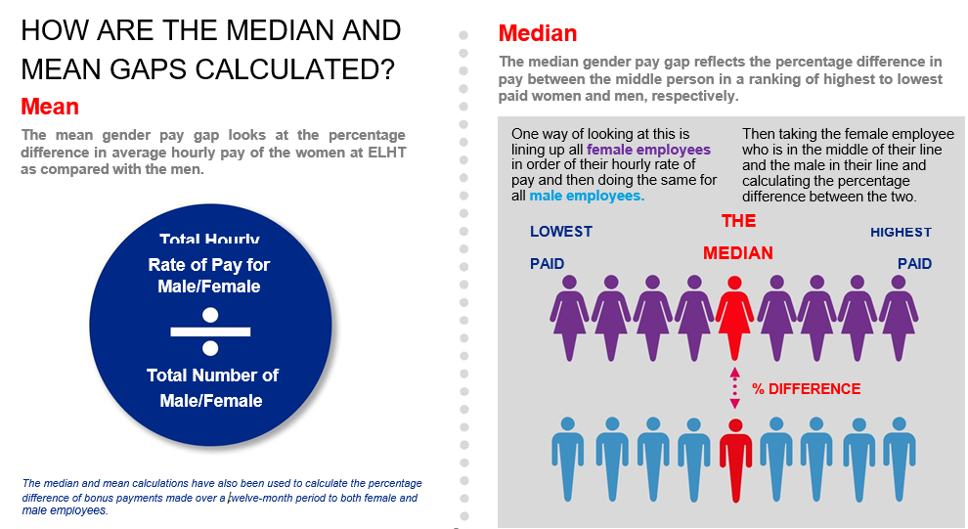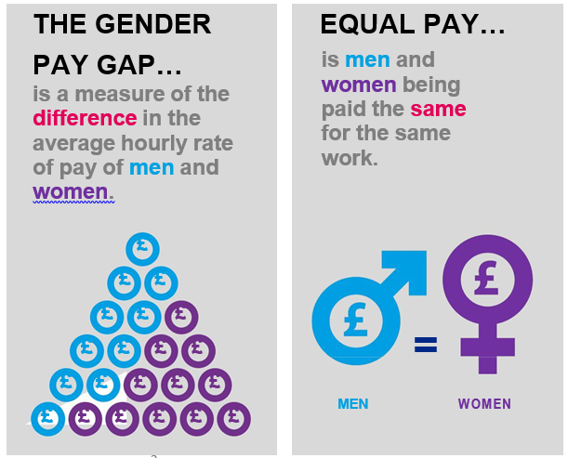

**Percentage of men and women in each hourly pay quarter**

|  |  |  |  |  |  |  |  |  |
| --- | --- | --- | --- | --- | --- | --- | --- | --- |
|  | **2020/21** | | **2021/22** | | **2022/23** | | **2023/24** | |
|  | **Men** | **Women** | **Men** | **Women** | **Men** | **Women** | **Men** | **Women** |
| Upper hourly pay quartile | 18 % | 82 % | 20% | 80 % | 21% | 79% | **21%** | **79%** |
| Upper middle hourly pay quartile | 17 % | 83 % | 19% | 81 % | 18% | 82% | **18%** | **82%** |
| Lower middle hourly pay quartile | 15 % | 84 % | 14% | 86 % | 15% | 85% | **15%** | **85%** |
| Lower hourly pay quartile | 27 % | 73 % | 27% | 73 % | 29% | 71% | **30%** | **70%** |

**4.2** The table above illustrates the gender distribution in ELHT across four equally sized pay quartiles. The lower quartile represents the lowest salaries in the Trust and the upper quartile represents the highest salaries. The data remains the same as the previous year. The Trust employs more women than men in every quartile.

**Average (mean) and median gender pay gap using hourly payap using hourly pay**

|  |  |  |  |  |  |
| --- | --- | --- | --- | --- | --- |
|  | **2019 to 2020** | **2020 to 2021** | **2021-2022** | **2022-2023** | **2023-2024** |
| Average (mean) gender pay gap using hourly pay | 25.92% | 25.69% | 22.84% | 22.92% | 22.51% |
| Median gender pay gap using hourly pay | 7.05% | 9.47% | 3.29% | 6.88% | 6.96% |

**4.3** The gender pay gap measured by the average hourly rate is 22.51% a decrease of 0.41% since the previous year.

**GPG Action Plan for 2024/25**

|  |  |
| --- | --- |
| **GPG High Priority Areas (Maximum 3)** | |
| **Priority 1** | Produce a more detailed GPG report that breakdown data for AFC bands, Medical/dental workforce, Part time v Full time, VSM, etc. |
| **Priority 2** | To analyse NHS Staff Survey data, particularly focussing on the experience of women. |
| **Priority 3** | Understanding and tackling the inequalities faced by women belonging to specific groups, based on characteristics such as ethnicity, age, deprivation and profession. |

**4.4** The work of Women’s Network is crucial in helping the Trust close the gap as they have been instrumental in informing the above actions. The women’s network engages its members to speak about the gap, and promotes good practice for tackling it. Without greater representation of women at the highest levels of leadership, it will be all but impossible to achieve true gender equality in ELHT for people at all stages of their careers.

Priorities for the network include:

* Implementation of the sexual safety
* career development
* wellbeing including the development of policies that support gender equality and women’s health and wellbeing.

**5. CONCLUSION**

**5.1** Implementing the WRES/WDES/GPG and acting on what the data tells us can have positive impact on improving our organisational culture, core to the Trust’s People Plan is creating an inclusive workplace environment where all staff feel a sense of belonging and everyone has the opportunity to contribute.

**5.2** There is a wide variety of evidence that draws links between increased staff satisfaction and improved patient outcomes; as staff will be happier and more likely to be able to excel at work. Consequently, we believe that if we are successful there will be an improvement in experience received by patients, relatives and carers.

**5.3** This is a constant journey and whilst a lot of activity has taken place over the last year, when considering our WRES/WDES/GPG journey, it is important to look at the metrics over time, this gives a fuller picture of how things are changing, looks beyond year-on-year fluctuations and more importantly what further progress we need to make to achieve these goals. When a single metric goes up or down each year by a small amount, this is unlikely to indicate an improving/declining trend and instead suggests there has been no significant improvement/decline.

**5.4** EDI risks are identified and adjusted based on the results of our analysis and staff stories. The Inclusion Group will aid the review of the associated risks and will advise of any adjustments, including to those on the BAF.

**5.5** Within the Trust the EDI data is not yet disaggregated by division to form part of the routine divisional performance reporting. This is vital if we are to start to make progress. Where there is local data, actions can start to spread, rather than relying on the actions of the corporate teams. This requires an education and development journey so that there is understanding of the issues and collective actions.

**5.6** The EDI Integrated action plan was developed late year and is being reviewed and reprioritised and will be taken to the Inclusion Group, which is the quarterly meeting to oversee progress of the inclusion agenda and hear back from the various staff networks. This plan will be shared with the People and Culture Committee at regular intervals. The Inclusion Group will therefore be able to highlight areas of risks and provide the committee with assurance against the Trust wide plan. The performance meetings also need to ensure that divisional priorities are identified, and actions tracked. It is recommended that when Divisions report on rotation to the Committee, that inclusion and belonging be an area of focus.

**5.7** The revised terms of reference for the Inclusion Group can be found in Appendix 5.

**6. RECOMMENDATIONS**

6.1 It is recommended that the People and Culture Committee:

* Note the content of this report
* Enable an accountability framework that Influences the implementation of the WRES, WDES and GPG improvement action plans at divisional, department, team and individual level
* Approve the submission and publication of the data on our corporate website, as per our contractual requirements.

**Author: Nazir Makda, Inclusion & Belonging Lead, June 2024.**

**Appendix 1 – WRES detailed results metrics 1 to 4 & 9**

|  |  |  |  |  |  |  |
| --- | --- | --- | --- | --- | --- | --- |
| **METRIC NUMBER AND DESCRIPTION** | **2021** | **2022** | **2023** | **2024**  **(Colours are Risk Key)** | | **Progress from**  **Last year** |
| **Metric 1: BME representation in the workforce by pay band** | |  |  |  |  | |
| BAME representation in the workforce overall | **19%** | **21%** | **22%**  **Better** | **26%** | | **▲** |
| **Metric 2: likelihood of appointment from shortlisting** |  |  |  |  | |  |
| Disparity ratio, likelihood of White staff being appointed compared to BAME people | **2.03** | **1.85** | **2.26** | **4.54** | | ▼ |
| **Metric 3: likelihood of entering formal disciplinary** | | | | | | |
| Disparity ratio, likelihood of BAME staff entering formal disciplinary process | **1.10** | **0.80** | **1.15** | **1.14** | | **▲** |
| **Metric 4: likelihood of undertaking non-mandatory training** | | | | | | |
| Disparity ratio, likelihood of BAME staff accessing non-mandatory training | **1.62** | **2.39** | **1.84** | **1.00** | | **▲** |
| **Metric 9: BME representation on the board** | | | | | | |
| BAME | **21.1%** | **28.8%** | **33.3%** | **23.53%** | | ▼ |
| White | **78.9%** | **72.2%** | **66.7%** | **76.47%** | |

|  |  |  |  |  |
| --- | --- | --- | --- | --- |
| **WRES Staff Survey results metrics 5 to 8**  **(Note staff survey data is always a year behind hence the most recent results are 2023)** | | | | |
|  | **2021** | **2022** | **2023**  **(Colours are Risk Key)** | **Progress from**  **Last year** |
| **Metric 5: Percentage of staff experiencing harassment, bullying or abuse from patients, relatives or the public in the last 12 months** | | | | |
| **BME**  **White** | 24.0% | 23% | **24%** | ▼ |
| 21.0% | 23% | **24%** |
| **Metric 6: Percentage of staff experiencing harassment, bullying or abuse from staff in last 12 months** | | | | |
| **BME**  **White** | 21.0% | 23% | **24%** | ▼ |
| 18.0% | 19% | **20%** |
| **Metric 7: Percentage of staff believing that the organisation provides equal opportunities for career progression or promotion** | | | | |
| **BME** | 50.0% | 50% | **52%** | **▲** |
| **White** | 64.1% | 66% | **65%** |
| **Metric 8: Percentage of staff experiencing discrimination at work from manager / team leader or other colleagues in the last 12 months** | | | | |
| **BME**  **White** | 14.0% | 14% | **15%** | ▼ |
| 5.0% | 6% | **7%** |

**Appendix 2: Workforce Disability Equality Standard (WDES) Detailed Data 2024**

|  |  |  |  |  |  |  |  |  |  |  |
| --- | --- | --- | --- | --- | --- | --- | --- | --- | --- | --- |
|  |  |  | **Trust Values** | | | | | **(Colours are Risk Key)** | | **Progress from**  **Last year** |
|  |  |  |
| **Metric number and description** | | | **2019** | **2020** | **2021** | **2022** | **2023** | **2024** | |  |
| **Metric 1: Disabled representation in the workforce by pay band** | | | |  |  |  |  |  |  |  |
| **Disability declaration rate in the workforce** | | **Overall** | **4.3%** | **3.3%** | **3.6%** | **4.0%** | **4.7%** | **5.17%** | | **▲** |
| Non-clinical | 3.4% | 3.6% | 4.0% | 4.3% | 5.1% | **5.1%** | |  |
| Clinical | 2.7% | 3.3% | 3.5% | 4.0% | 4.7% | **5.03%** | |  |
| Medical/Dental | 0.8% | 2.0% | 2.4% | 2.8% | 3.0% | **1.06%** | |  |
| **Metric 2: Likelihood of appointment from shortlisting** | | | |  |  |  |  |  |  |  |
| Likelihood ratio Non-disabled / Disabled | | |  | 1.05 | 1.13 | 0.88 | 0.83 | **0.67** | | **▲** |
| **Metric 3: Likelihood of entering formal capability process due to performance management** | | | | | | |  |  |  |  |
| Likelihood ratio Disabled / Non-disabled | | |  | 3.50 | 0.00 | 0.00 | 0.00 | **0.00** | | **-** |
| **Metric 10: Disabled representation on the board** | | |  |  |  |  |  |  |  |  |
|  | **Overall** | Members | 1 | 1 | 1 | 1 | 2 | **1** | |  |
|  | Proportion | 5.9% | 5.6% | 5.3% | 5.6% | 11.1% | **5.88%** | | **▲** |
|  | **Exec** | Proportion | 0.0% | 0.0% | 0.0% | 0.0% | 12.5% | **10.00%** | |  |
|  | **Non-exec** | 9.1% | 33.3% | 11.1% | 10.0% | 10.0% | **0.00%** | |  |
|  | **Voting** | 0.0% | 0.0% | 0.0% | 0.0% | 9.1% | **8.33%** | |  |
|  | **Non-voting** | 14.3% | 16.7% | 20.0% | 16.7% | 14.3% | **0.00%** | |  |

|  |  |  |  |  |  |  |  |
| --- | --- | --- | --- | --- | --- | --- | --- |
| **WDES staff survey results**  **(Note staff survey data is always a year behind)**  **Indicator number and description** | | **2019** | **2020** | **2021** | **2022** | **2023**  **(Colours are Risk Key)** | **Progress from**  **Last year** |
| **Metric 4a: Harassment, bullying or abuse from patients, relatives or the public in last 12 months** | | | | | | |
| Staff with a LTC or illness | | 30.9% | 31.1% | 28.5% | 29.7% | **33.6%** | ▼ |
| Staff without a LTC or illness: | | 22.1% | 21.4% | 21.9% | 21.5% | 21.3% |
| **Metric 4b: Harassment, bullying or abuse from line managers in last 12 months** | | | | | | |
| Staff with a LTC or illness | | 16.1% | 16.8% | 15.5% | 12.3% | **17.0%** | ▼ |
| Staff without a LTC or illness: | | 8.3% | 8.7% | 6.9% | 7.6% | 6.9% |
| **Metric 4c: Harassment, bullying or abuse from other colleagues in last 12 months** | | | | | | |
| Staff with a LTC or illness | | 24.3% | 25.1% | 21.9% | 22.7% | **27.0%** | ▼ |
| Staff without a LTC or illness: | | 14.2% | 13.3% | 11.8% | 13.2% | 13.6% |
| **Metric 4d: Reporting last incident of harassment, bullying or abuse** | | | | | | |
| Staff with a LTC or illness | | 52.9% | 55.8% | 45.9% | 48.3% | **55.9%** | **▲** |
| Staff without a LTC or illness: | | 49.2% | 49.4% | 49.3% | 48.3% | 50.1% |
| **Metric 5: Career progression** | | | | | | |
| Staff with a LTC or illness | | 55.7% | 58.3% | 54.9% | 57.4% | **54.8%** | ▼ |
| Staff without a LTC or illness: | | 65.3% | 65.5% | 63.7% | 64.8% | 65.3% |
| **Metric 6: Presenteeism** | | | | | | |
| Staff with a LTC or illness | | 29.7% | 33.1% | 31.7% | 32.3% | **33.7%** | ▼ |
| Staff without a LTC or illness: | | 20.0% | 25.1% | 24.3% | 24.7% | 23.5% |
| **Metric 7: Feeling valued** | | | | | | |
| Staff with a LTC or illness | | 45.2% | 41.9% | 32.6% | 35.1% | 36% | **▲** |
| Staff without a LTC or illness: | | 59.3% | 53.9% | 47.6% | 47.6% | 48% |
| **Metric 8: Reasonable adjustments** | | | | | | |
| Staff with a LTC or illness | |  |  | 78.0% | 74.1% | **71.7%** | ▼ |
| **Metric 9a: Staff engagement** | | | | | | |
| Staff with a LTC or illness | | 6.84 | 6.87 | 6.59 | 6.51 | **6.40** | ▼ |
| Staff without a LTC or illness: | | 7.36 | 7.25 | 7.11 | 7.12 | 7.06 |

**Appendix 3 - WRES Infographics (To be shared with the wider workforce)**

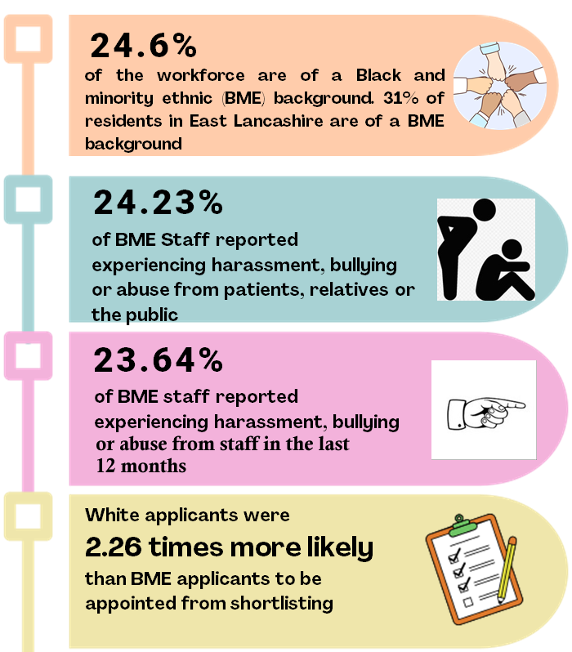

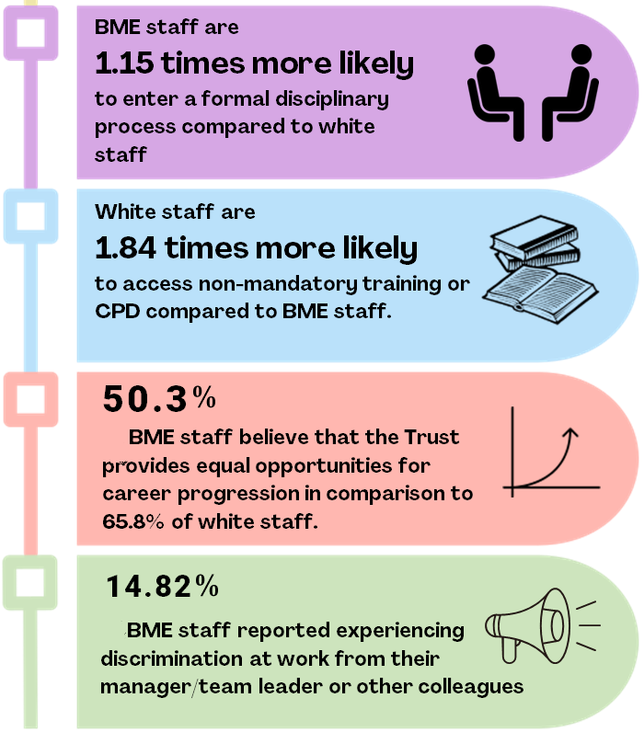

**Appendix 4 - WDES Infographics (To be shared with the wider workforce)**

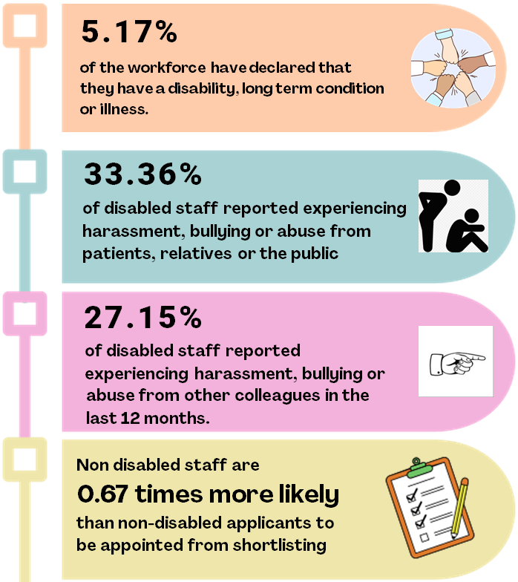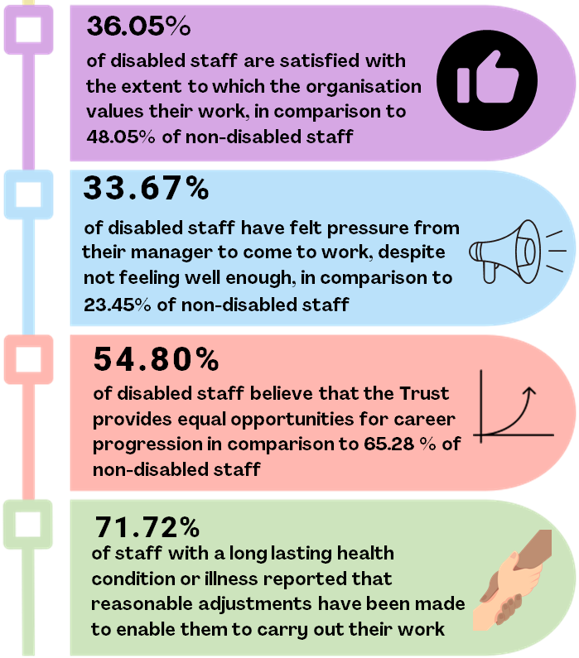

**Appendix 5 –Inclusion and Belonging Group** **Terms of reference**

**1. Vision**

1.1 The Inclusion and Belonging Group aims to embed equality, diversity, and inclusion (EDI) across all Trust activities, creating an environment where everyone feels included and that they have a sense of belonging within ELHT.

**2. Purpose**

2.1 The Group's objectives include:

* Providing strategic direction, leadership, and support for the Trust’s EDI agenda.
* Ensuring strategies are in place to maintain a high-performing, engaged, and motivated workforce with a culture free from discrimination.
* Managing risks related to "protected characteristics" and the "public sector equality duty" as per the Equality Act 2010, NHS codes, and best practices.

**3. Role of the Group**

3.1 To inspiring inclusive leadership, removing barriers to change, celebrating success, and highlighting important events via the **Annual Inclusion Calendar**.

3.2 To provides a forum for raising and discussing EDI issues, ensuring actions align with Trust’s strategic objectives, vision, values, and broader NHS strategies.

3.3 To use data and intelligence to identify priority areas through qualitative and quantitative analysis.

3.4 To monitor and provide assurance to the People and Culture Committee and Senior Leadership Teams of the Trust’s compliance with EDI legislation and regulations.

3.5 To recognise **Staff Networks** as vital for driving meaningful change and creating inclusive cultures.

3.6 To receives assurances from divisions and directorates on their EDI performance, including compliance with NHS codes of practice and statutory requirements.

3.7 To agree an annual work plan. Priorities include:

* Anti-Racism Strategy and Clinical Quality Academy improvement project;
* Developing a process for managing Reasonable Adjustments;
* Developing an Inclusive Recruitment Toolkit;
* Tackling health inequalities;
* Developing an Allyship framework;
* Developing an EDI dashboard;
* Implementing various NHS standards and reporting requirements.

3.8 To consider opportunities, challenges, and requirements from the Trust, Integrated Care Systems, and partnerships.

**4. Membership**

|  |  |
| --- | --- |
| **Substantive Role** | **Inclusion Group Role** |
| ELHT Chair | Chair |
| Exec Director for People & Culture | Vice – Chair |
| Non-Exec Director | Member |
| Director of Nursing Representative | Member |
| Associate Director of OD, Inclusion, and Transformation | High level Support |
| Deputy Director of Integrated Care, Partnerships & Resilience or Representative | Member |
| Patient Experience Representative | Member |
| Deputy Director of HR | Member |
| Medical Director Representative | Member |
| EDI Lead | High Level Support |
| Workforce Transformation Manager | Support |
| PA & HR Administrator | Secretariat support |
| OD and Inclusion - Graduate Management Trainee | Support |
| Head of HR | Member |
| Head of Employment Services | Member |
| Head of Occupational Health | Member |
| Freedom to Speak Up Office | Member |
| Divisional and Directorate Nominated Representatives | Members |
| Staff Side Representatives | Members |
| Staff Network Nominated Co-Chairs | Members |
| Chaplaincy Representative | Member |
| Communications Representative | Member |
| People Promise Manager / Staff Experience Lead | Member |
| Quality Improvement Representative | Member |
| Governance and Safety Representative | Member |

**5. Quorum and Frequency**

5.1 The quorum necessary for the meeting to go ahead the Chair or Co-Chair and at least 75% of the members.

5.2 The Group will meet quarterly and review its effectiveness annually.

**6. Reporting Arrangements**

6.1 The Inclusion Group reports to the People and Culture Committee but may report directly to senior management or the Trust Board as needed.

6.2 Updates will be provided through meeting minutes, a quarterly EDI Dashboard, and an annual report.

**7. Attendance at Meetings**

7.1 Members are expected to attend at least 50% of meetings annually. This will be reported to the People and Culture Committee.

**8. Monitoring of Effectiveness**

8.1 The group will review its terms of reference annually to ensure effective operation and alignment with its objectives.